Week 18 Homework

Step 1: The Need for Speed

1. Eval command: eval ratio=(DOWNLOAD_MEGABITS/UPLOAD_MEGABITS)  
     
   Table

   Description automatically generated
2. Create a report: table _time, IP_ADDRESS, DOWNLOAD_MEGABITS, UPLOAD_MEGABITS, ratio  
   Graphical user interface, table

   Description automatically generated
3. Answer the following questions.
   1. Based on the report created, what is the approximate date and time of the attack? **02/23/2020 14:30:00 (2:30 PM)**
   2. How long did it take your systems to recover?  
      **6 Hours. It begins to pick up speed at 02/23/2020 20:30:00 (8:30 PM)**Graphical user interface, table

      Description automatically generated

Step 2: Are We Vulnerable

1. Create a report that shows the count of critical vulnerabilities from the customer database using the severity field and the destination IP address of the database (10.11.36.23).

**source="nessus_logs.csv" host="Nessus_Scan" sourcetype="csv" dest_ip="10.11.36.23" severity="*"|stats count by severity**  
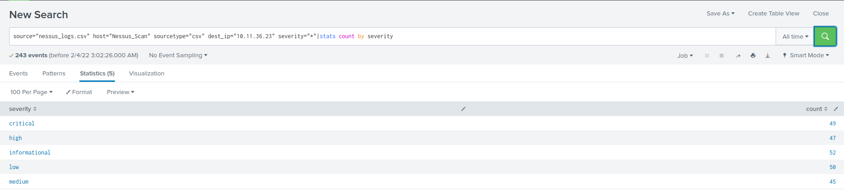

1. Build an alert that emails [soc@vandalay.com](mailto:soc@vandalay.com)

Step 3: Drawing the (base)line

1. When did the brute force attack occur?

**The brute force attack occurred February 21, 2020 9 AM – 2 PM.**

1. Determine a baseline of normal activity and a threshold that would alert if a brute force attack is occurring.

**Baseline: > 25 (Set to this because it does seem to go beyond that unless it’s before and after a brute force attack)**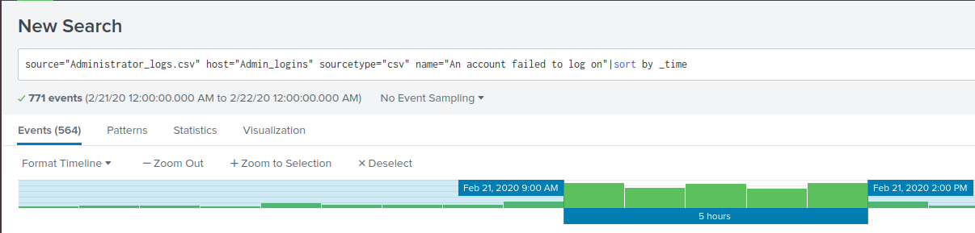

1. Design an alert to check the threshold every hour and email the SOC team if triggered.

